**ATLANATA POPULATION**

1. **Db.zipcodes.find({$and:[{city:'ATLANTA'},{state:'GA'}]})**

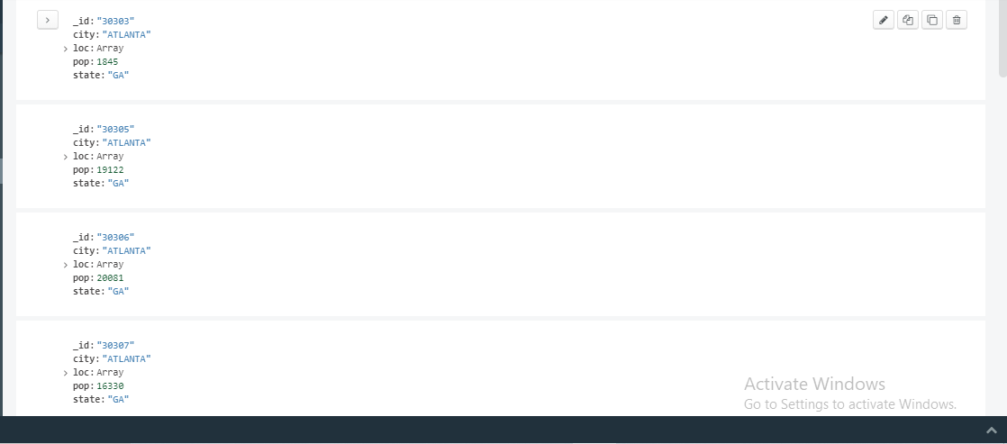

**2. db.zipcodes.aggregate([{$match:{$and:[{city:'ATLANTA'},{state:'GA'}]}}])**

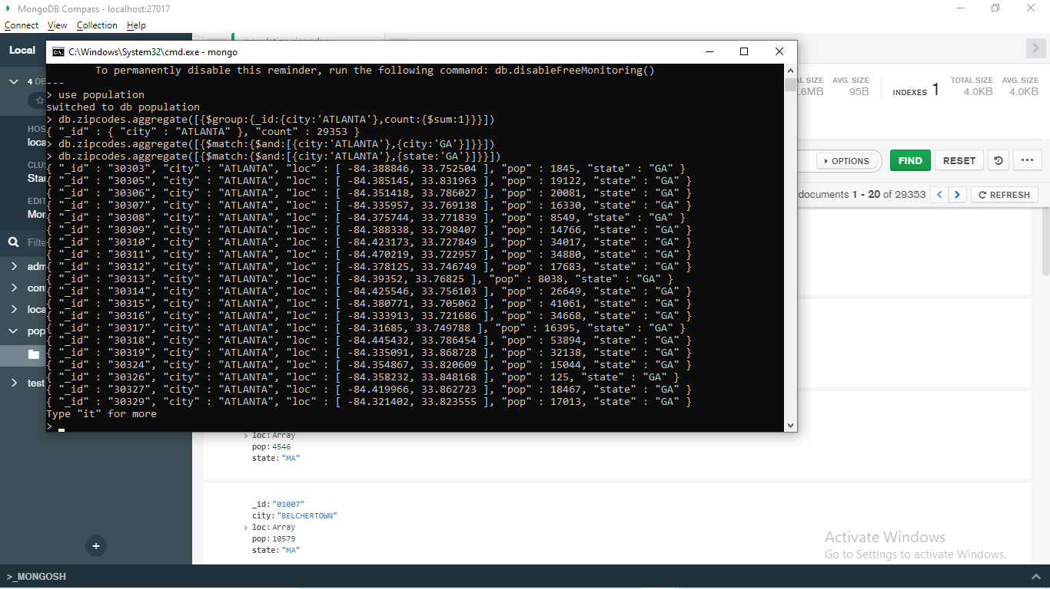

**3. db.zipcodes.aggregate([{$group:{_id:{city:'ATLANTA'},count:{$sum:1}}}])**

**Screenshot (68).png**

**4. { "_id" : { "city" : "ATLANTA" }, "totalpopulation" : 248408400 }**

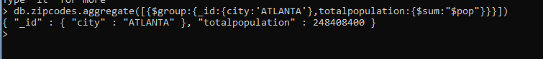

**POPULATION BT STATE**

1. **db.zipcodes.aggregate([{$group:{_id:"$state",population:{$sum:"$pop"}}}])**

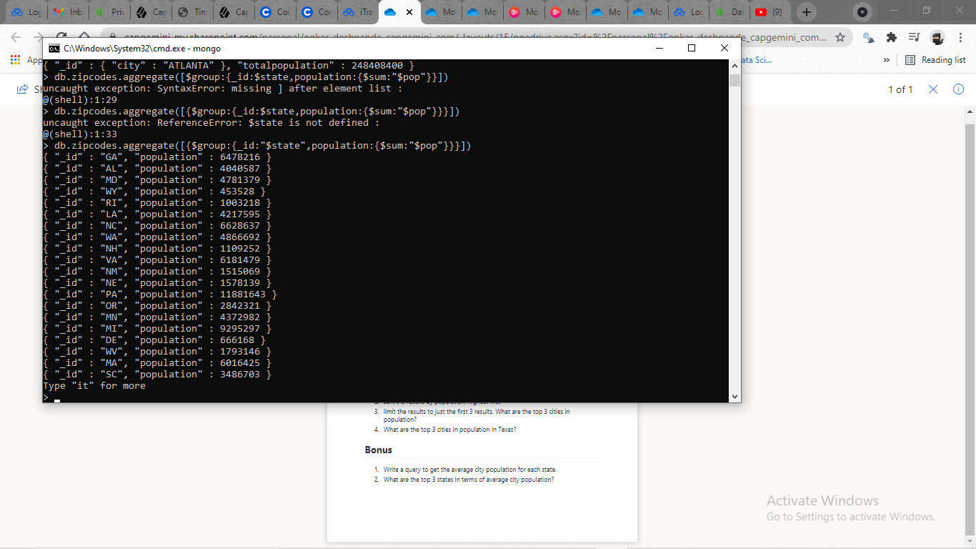

1. **db.zipcodes.aggregate([{$group:{_id:{city:"$city",state:"$state"},population:{$sum:"$pop"}}},{$sort:{population:-1}}])**

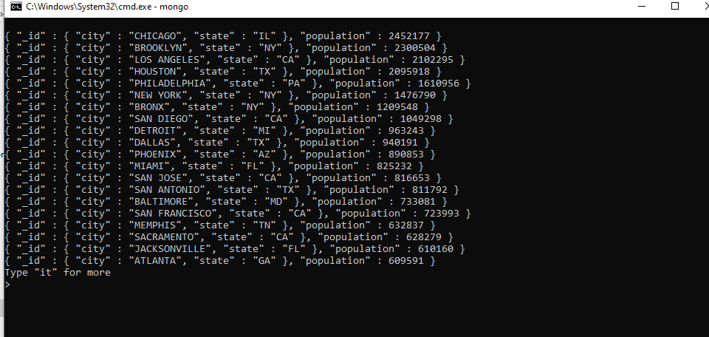

1. **db.zipcodes.aggregate([{$group:{_id:{city:"$city",state:"$state"},population:{$sum:"$pop"}}},{$sort:{population:-1}},{$limit:3}])**

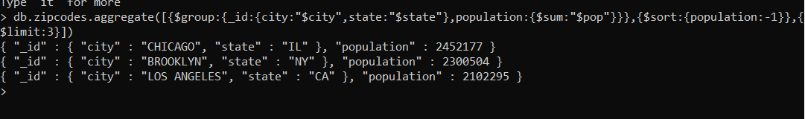

**POPULATION BY CITY**

1. **db.zipcodes.aggregate([{$group:{_id:{city:"$city",state:"$state",Average:{$sum:"$pop"}}}}])**

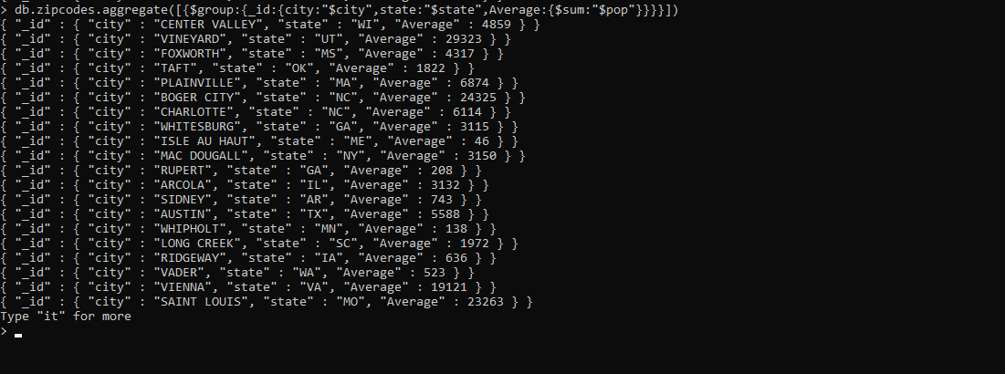

**2. db.zipcodes.aggregate([{$group:{_id:{city:"$city"},population:{$sum:"$pop"}}},{$sort:{population:-1}}])**

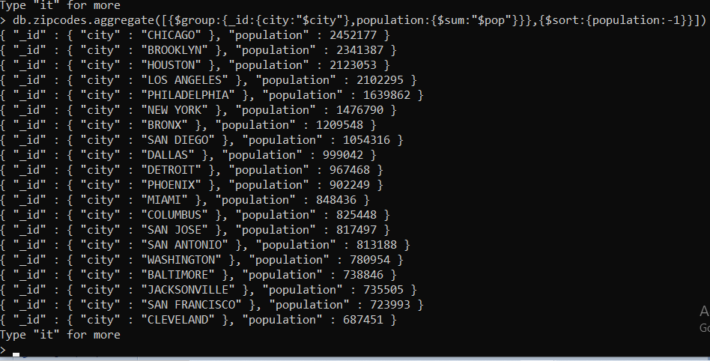

**3.**

**db.zipcodes.aggregate([{$group:{_id:{city:"$city"},population:{$sum:"$pop"}}},{$sort:{population:-1}},{$limit:3}])**

{ "_id" : { "city" : "CHICAGO" }, "population" : 2452177 }

{ "_id" : { "city" : "BROOKLYN" }, "population" : 2341387 }

{ "_id" : { "city" : "HOUSTON" }, "population" : 2123053 }

**4.**

**db.zipcodes.aggregate([{$group:{_id:{city:"$city",state:"Texas"},population:{$sum:"$pop"}}},{$sort:{population:-1}},{$limit:3}])**

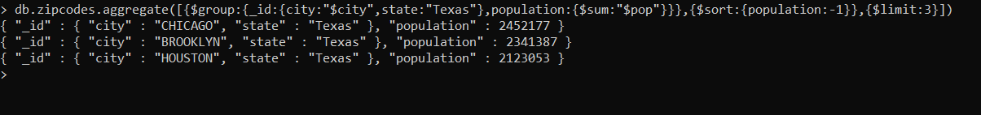

**Bonus**

1. **db.zipcodes.aggregate([{$group:{_id:{city:"$city",state:"$state",Average:{$avg:"$pop"}}}}])**

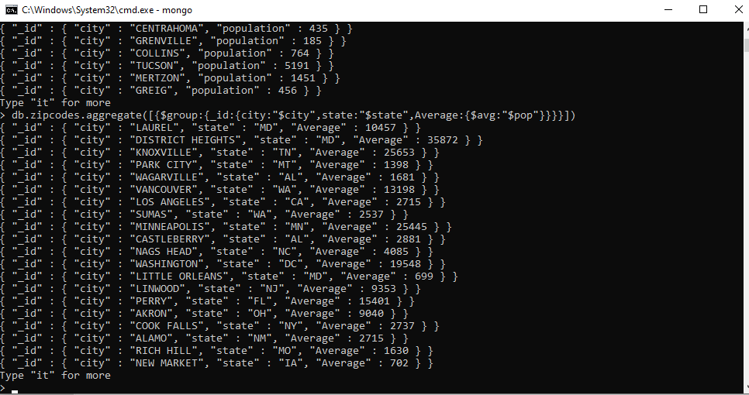

1. **db.zipcodes.aggregate([{$group:{_id:{city:"$city",state:"$state",Average:{$avg:"$pop"}}}},{$limit:3}])**

{ "_id" : { "city" : "SAN LORENZO", "state" : "CA", "Average" : 23010 } }

{ "_id" : { "city" : "LAMAR", "state" : "OK", "Average" : 225 } }

{ "_id" : { "city" : "GRAND ISLAND", "state" : "FL", "Average" : 1416 } }